
PYTHON PROGRAMMING LAB FILE

Name: Krishna Som
Sap ID: 590025475
Batch: 34
Teacher: Sugandha Sharma

Q1. Write a Python program to check if a given integer is divisible by both 3 and 5.
Code: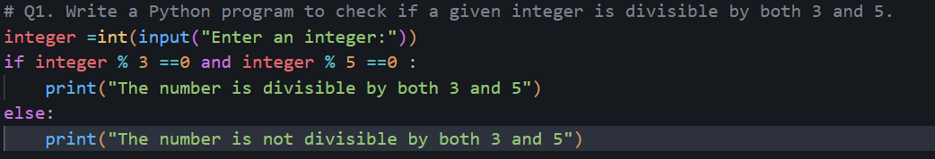
Output:
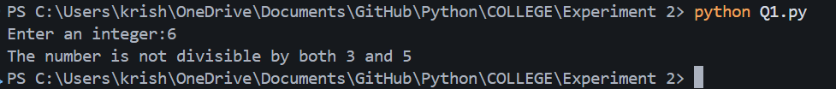

Q2. Check if a number is divisible by 5.
Code:
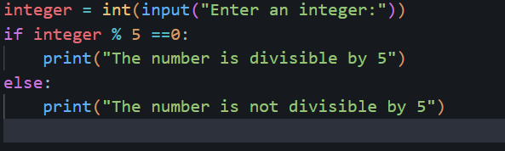
Output:
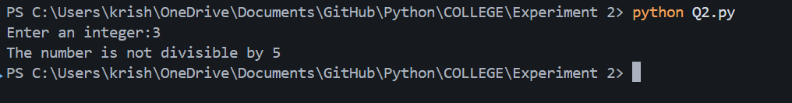

Q3. Check between two number which is bigger.
Code:
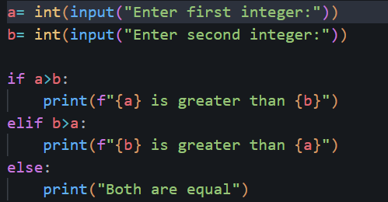
Output:
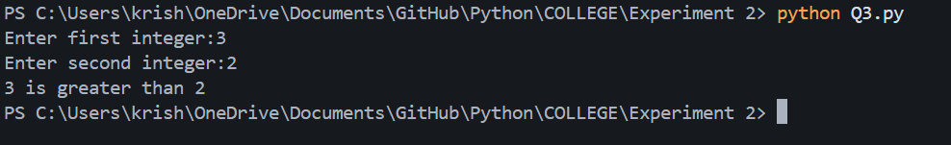

Q4. Find the greatest among three numbers assuming no two values are same.
Code:
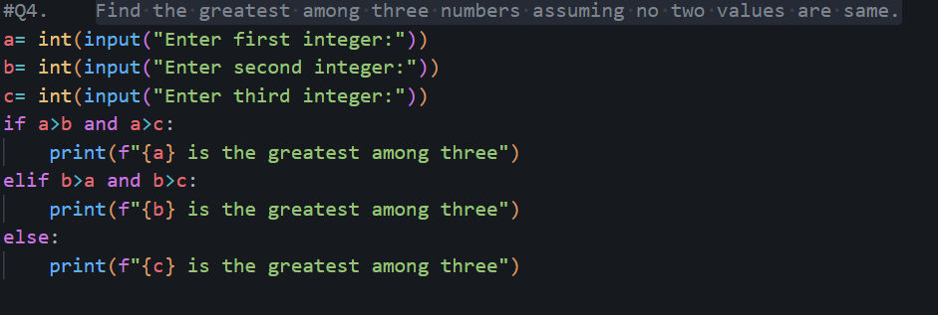
Output:
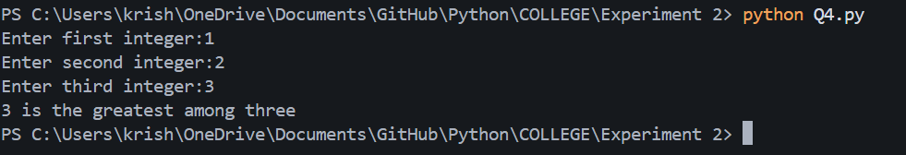

Q5. Check whether the quadratic equation has real roots or imaginary roots. Display the roots.
Code: 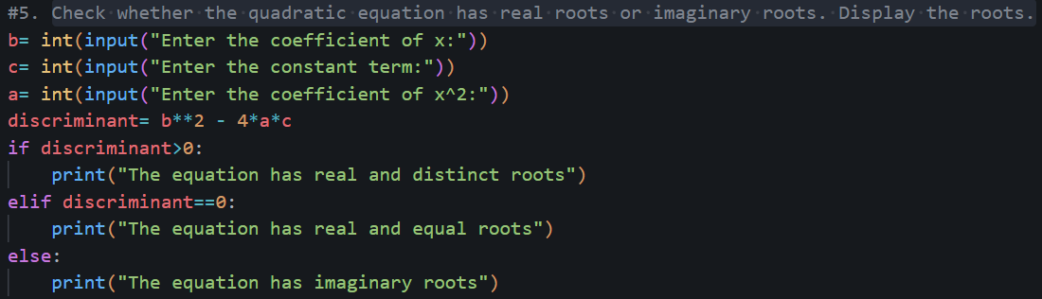
Output:
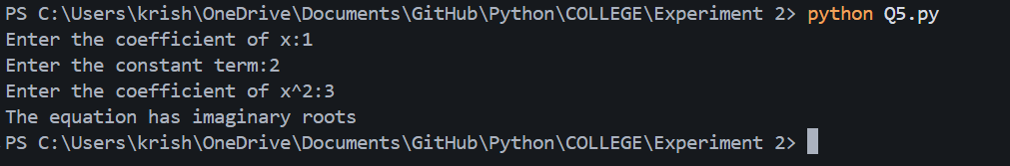
Q6. Find whether a given year is a leap year or not.
Code:
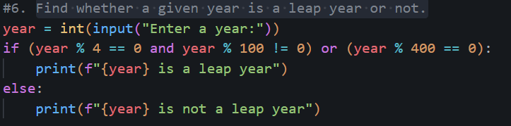
Output:
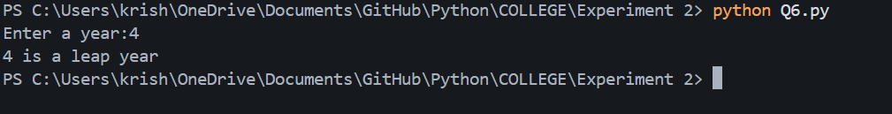

Q7. Write a program which takes any date as input and display next date of the calendar.
Code:
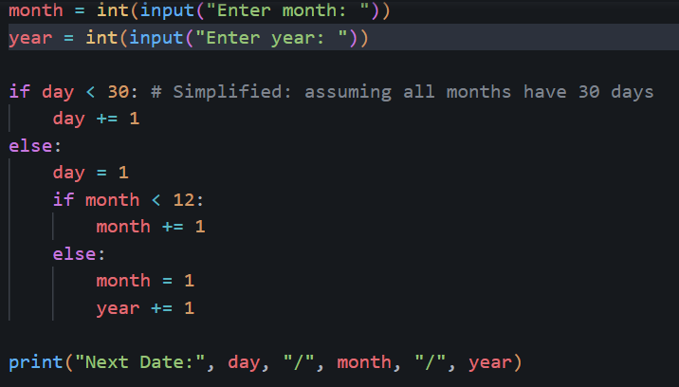
Output:
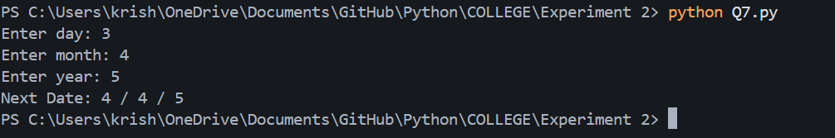

Q8. Print the grade sheet of a student for the given range of cgpa. Scan marks of five subjects and calculate the percentage.
Code:
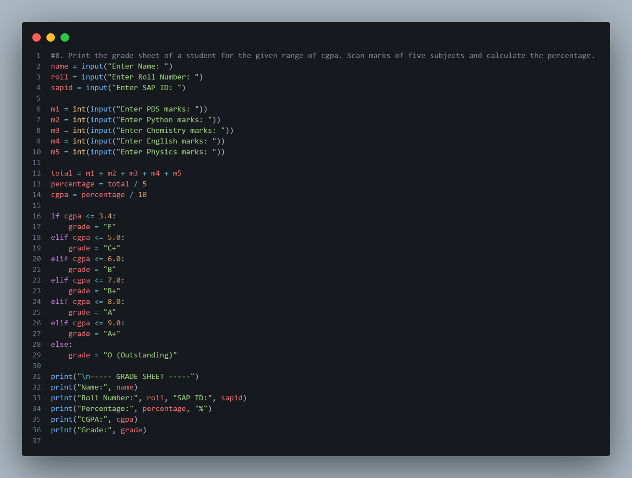

Output:
